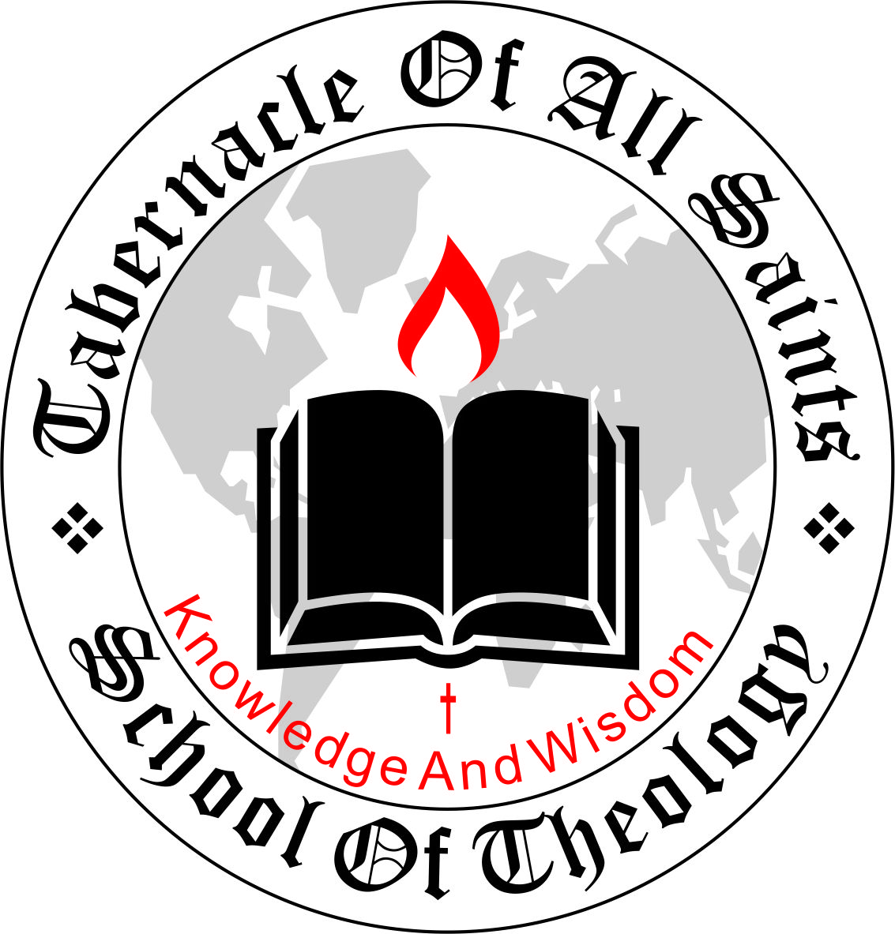

STUDENT
HAND BOOK

If you wish to print this document, please be informed that it has been optimized for reading on-screen.

This EBook has been optimized for reading On-screen. If you wish to print it, then choose A5 as the paper-size. If you choose any other size, the printer will try to ‘fill’ that page and will give an ugly look!!

Tabernacle of All Saints School of
Theology

Dear Student,
Welcome to TOASST student body. The fact that you received this handbook means you have already submitted your admission form and you have been admitted into the institution. This Student Handbook will help to give you instructions about your assignments plus submission of assignments. Let me also congratulate you on your admission into Tabernacle of All Saints School of Theology! Please read this document as many times as needed to internalize the instructions so as to maximize your academic experience with TOASST as meaningful as possible. Please consult this handbook before you contact the office for clarification. We have made this handbook as comprehensive as possible, and have taken frequently asked questions in consideration. Thus an effort on your part to read this Handbook can save the office the time it has to spend to answer your questions which are already answered here. We have formatted this Handbook for A5 size paper which is half of the commonly available A4 size. A5 is available in larger office supply shops. It can be printed on A4 also provided you do not choose „fit to margin‟ option in your printer. It is a good idea print and keep a copy with you for handy reference.
ABOUT THE SCHOOL:
TABERNCLE OF ALL SAINTS SCHOOL OF THEOLOGY (TOASST) is a Theological College that’s fully and duly registered with the Corporate Affairs Commission (CAC) in Nigeria, with the registration Number: 8918861, based in Lagos Nigeria.
The establishment of the school occurred as a result of a prophetic direction of the Holy Spirit given to the
Pioneer president, Rev. Dr. Matthew Uchenna Ifediegwu, who since after committing himself to Christ in 2007 has been serving the Lord at different levels. TABERNCLE OF ALL SAINTS SCHOOL OF THEOLOGY (TOASST) was formed with the purpose of building, equipping and strengthening the body of Christ.
ACCREDITATION:
Tabernacle of All Saints School of Theology (TOASST) is a fully registered institution and a strong member of Association of Independent Christian Colleges and Seminaries. However, every student must understand that the nature and purpose of TOASST is centered purely on religious purposes and of course, any Degree, Diploma or Certification program increases marketability because it demonstrates a disciplined devotion to a system of study. However, you as a student need to look ahead and investigate what you want the Degree, Diploma, or Certification to do for you. Likewise, students who desire to transfer our credits and degrees to other colleges may or may not have success in doing so. It is at the discretion of each learning institute to determine this. Our main aim is to train and equip you for ministry work.
AFFILIATION:

TABERNCLE OF ALL SAINTS SCHOOL OF THEOLOGY
(TOASST) is committed to the doctrinal beliefs of RIGHTEOUS TENT CHRISTIAN CHAPEL (RTCC) However, the right of each student to affiliate with another evangelical, Pentecostal and charismatic or any other denomination is respected. The College codes of conduct are based upon the teachings and principles of the scriptures, seeking to develop personal holiness and discipline exemplified in a lifestyle glorifying to God. The College imparts spiritual knowledge and teaches biblical values both of which promote the traditions of evangelical, Pentecostal and charismatic churches.

MODE OF INSTRUCTION:
The program shall comprise of lectures, seminars, field projects and 2 months period of internship in a Ministry or Church organization.

COMMUNICATION:
Since TOASST is BOTH offline and online school, and since it has its own problems, you need to understand communication protocols right from the start. Here are the points that you need to understand:
- All emails sent to TOASST (whether it is to the office, or to an Individual in the office) should contain your full name, the course in which you are enrolled, and the full address.
- Create a signature-file with all the above information and save it on your computer. Copy and paste it at the end of every communication with TOASST
- The full address is needed because often the answer from the office will depend upon the country of your origin/residence because many requirements vary from country to country.
- Unless you include full information in your email, the office will find it difficult to locate your files.
- Some students simply return the email with whatever
“Subject” it originally had. They do not write the new subject which they wish to discuss. This is a mistake. Incoming emails are filtered according to the subject line and you need to indicate the correct “subject” in all emails.
- A little bit of thoughtfulness on your part at this stage will save TOASST a good amount of time, and will expedite the reply from the office.
- Emails to or fro do get lost at times, in spite of the current technological sophistication, and you might have to send reminders at times to the office.
ASSIGNMENTS AND HOW TO GO ABOUT THEM:
TOASST has evolved a method of assignments, which is given below. It may look simple, but that is not the reality, and the students have to work hard and on a regular basis if they have to meet the expectations of the Mentors. We follow the open Textbook approach. This also means that the assignments are assessed on stricter criteria than in normal exams. The following is your assignment for each module:
The assignment will be sent to you via e-mail, whatsAPP or any other method of communication you provided during your registration, you will return the assignment through the same channel after it has been completed within seven days.

COMPULSLY THING THAT ALL THE STUDENTS MUST DO:
All TOASST students need to do a few things. Note them down, make a time-table and follow the time-table strictly.
The first thing you need to do is to join Facebook and WhatsAPP groups the address to these various groups will be communicated to you during registration. This is a fast method for TOASST to communicate brief news with you.
GRADING AND COMMUNICATION:
The assignments are sent to different faculty members as soon as they reach us. Results are communicated as soon as we get them back.
- Since OUR INSTRUCTORS are all voluntary faculty members, and since they all work full-time in different institutions to meet their financial needs, at time there would be some delay in grading and communicating the results.
- Students should bear with this, because it is their willingness to help voluntarily that make tuition-free education possible at TOASST.
- The results are communicated in a grade chart without any comment if the work is of a satisfactory level.
- If the examiner feels you need to improve, the comments to that effect made by him will be communicated to you.
PRACTICAL WORKS:
All students will have to submit written courses as part of their practical work. Please note the following about it:
- All students need to develop a certain number of Bible courses as part of their practical work.
- Instruction for developing the practical work comes automatically to you from TOASST School private mailing list for students.
- Once you receive these instructions, follow them strictly. Do not try to take liberties.

